Team name: Project4

Scrum Master: Marc

Date:16 April 2019

|  |  |  |  |
| --- | --- | --- | --- |
| **Team Member** | **What did you do since the last scrum?** | **What do you plan to do before the next scrum?** | **What obstacles do you have?** |
| Jeffrey | refactoring node.js code | integrate database to server with Brandon | Running all tests  other classes |
| Marc | Unit Testing | More Unit Testing  CSS | Unit testing. Where to end and start. |
| Jazlyn | Updated Documentation  CSS | -Make sample games show up with EJS  -Change css | getting information from server |
| Brandon | enabled DB to talk with server. | updating DB and and tables for DB | getting the requests formed right to get information |

Burndown:

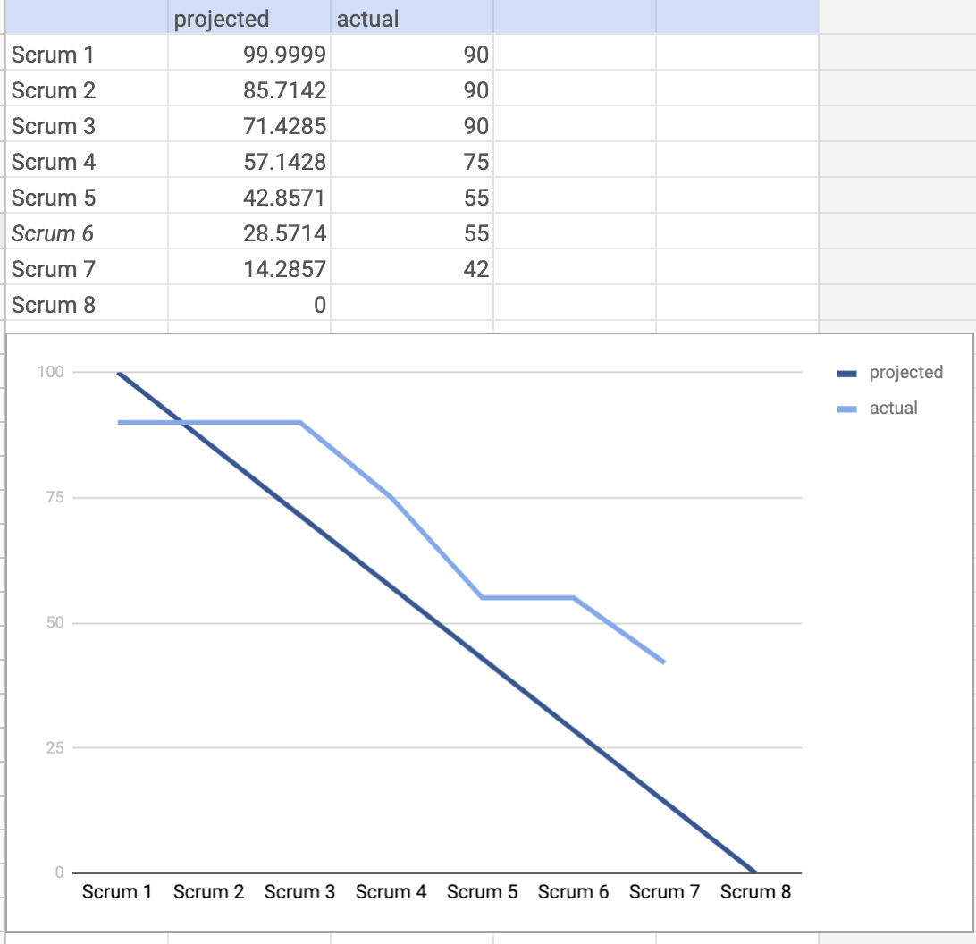

Screenshot of your task board: